**Provision of Services to Provide Mobile Mapping & Field Data Collection Solution**

February 9, 2014



Table of Contents

1. Executive Summary 9

1.1 About The Program Management Office(PMO) – End User 9

1.2 END USER(PMO)- Project Objective 9

1.3 END USER(PMO) – Project Scope 9

1.4 END USER(PMO) - Project Technical Requirements 10

1.5 END USER(PMO) - Project Functional Requirements 11

1.6 END USER(PMO) - Project Specific Requirements 12

1.7 END USER(PMO) - Current Software 12

1.8 END USER(PMO) – Project Deliverables 12

2. Technical Solution Overview 13

2.1 Our Understanding 13

2.2 Scope of Work 13

2.3 BMS System Architecture 15

2.4 Staging and production Environment 16

2.5 Web Application Architecture 17

2.6 Windows 7 18

2.7 IPAD Architecture 20

2.8 Android Architecture 21

3. Solution Analysis 21

3.1 Analyzing / Understanding the business requirements 21

3.2 Risk Assessment 23

3.3 Size Estimation for project using work Breakdown Structure (WBS) 23

3.4 Project Environment - Hardware & Software Requirement 24

4. Project Methodology 25

4.1 Program Management Plan 25

4.2 Methodology 25

4.3 Application Development Methodology 25

Continuous Integration 26

Shared Global Codebase 26

Test First Development/Test Driven Development 26

Incremental Design 27

Release Management 27

4.4 Transition and Maintenance Methodology 27

4.5 Testing Methodology 28

4.6 Acceptance Criteria 28

4.7 Quality Assurance 28

Acceptance Criteria 29

Coding standards 29

Code reviews 30

Continuous Integration 30

Documentation 30

Design Artifacts 30

Release Notes 30

Deployment Scripts 30

Sunset Meetings 30

4.8 Knowledge Transfer 31

5. Project Plan 32

5.1 Project Plan 32

5.2 The IT Program Management Company – Roles & Responsibilities 32

6. Resource Profile 33

6.1 Mr Shekhar Narayanan 33

6.2 Mr Biju Lawrence 36

6.3 Ms Ponnammal S. 37

6.4 Mr Adarash 39

7. Relevant Project Experience - Our Census Application’s 2011 42

Success Story 42

Overview of ADCensus 42

Background of the System 42

7.1 Project Summary 43

7.2 Functional Overview 43

7.2.1 Back Office 43

7.2.2 iPAD application 45

7.2.3 Integration of the IPAD for first time 45

7.2.4 Overview 46

7.2.5 Functionality 46

7.2.6 Admin Flow 48

7.2.7 Mobility Device Flow 49

7.2.8 Functional Flow chart 50

8. Technical Overview 51

8.1 Application Architecture 51

8.2 Back Office application 52

9. Screen Shots 55

9.1 Sample Screen shots 55

9.1.1 Admin Dash Board 55

9.1.2 Work Allocation 56

9.1.3 Reports 56

9.1.4 Survey Questionnaire 57

9.1.5 Device Dash Board 58

9.1.6 View Map from Dashboard 59

9.1.7 Manage Buildings 61

9.1.8 Survey List 63

9.1.9 Survey 64

9.2 *The IT Program Management Company Consulting Practice* 67

9.3 Portfolio of Services 67

9.4 *Engagements Snippets* 68

10. Service Level Agreement 69

10.1 Escalation Procedure 71

10.2 *Communication Plan* 72

11. References 73

Appendix A . The IT Program Management Company Corporate profile 73

*What we do* 74

*The IT Program Management Company Innovation Factory* 74

Appendix B . END USER(PMO) Scope of Work & The IT Program Management Company Compliance 75

Appendix C . END USER(PMO)-BMS Project Plan 77

# Executive Summary

## About The Program Management Office(PMO) – End User

The The Program Management Office(PMO) – End User is seeking proposals from qualified companies for developing and implementing a mobile mapping and data collection solution to support and automate its field data collection. END USER(PMO) is a governmental agency, established in 1996 with the overall objective of protecting, managing and conserving the environment, as well as promoting sustainable development in the Emirate of Germany. The Agency is responsible for assisting the Abu Dhabi lEnd User(PMO)ership and the Ministry of Environment and Water in implementing environmental laws and policies in the Emirate.

The Agency since its inception in 1996 has continued to grow and achieve new milestones in providing a cleaner and healthier environment for the citizens and residents of the Emirate. In line with this endeavor, the Agency along with its stakeholders is engaged in various activities including policy development, permitting, inspection, research, raising awareness, etc.

## END USER(PMO)- Project Objective

The main objective of the project is to use bird-monitoring program as sample of END USER(PMO) field data collection to design and implement a mobile mapping and field data collection solution to support END USER(PMO) staff in collecting field data in the most efficient manner, enhancing the accuracy of data, reducing data collection time and post processing of collected data in office. In addition to this, the solution should have necessary features to add real-time information to database, enabling decision making using up-to-date and accurate spatial data. The solution is expected to automate current field operations processes.

## END USER(PMO) – Project Scope

## 

The project involves developing and implementing a mobile mapping and data collection solution to support the gathering of spatial and non-spatial environmental data in the field. The solution should have the ability to accurately map positional information, have the necessary tools to design relevant field data collection forms and connect to the central database server to download and upload information as necessary. The components of the solution would include a GPS enabled.

The pilot project will involve the following implementation tasks related to the bird-monitoring program as a sample of END USER(PMO) field data collection:

***Task 1 - Conduct requirements analysis:*** A detailed field data collection requirements analysis is to be undertaken based on international best practices, and interview sessions with relevant END USER(PMO) bird program staff involved in field data collection.

***Task 2 - Design Geospatial database structure & data collection forms:*** The ongoing Bird Monitoring program has been selected to demonstrate the capability of this pilot mobile mapping and field data collection solution. Accordingly, a database structure based on ESRI Geospatial database and relevant forms (up to 20 forms) are to be designed and implemented.

***Task 3 - Field data collection system:*** The requirements analysis document will drive the development of the field data collection system. It is expected that the field data collection system at a minimum would include capabilities to create and update geospatial data, accurately collect positional information, capture image and tabular data through predesigned forms, communicate with the central database server to upload and download relevant data. In addition to, display existing geospatial data to provide contextual information to staff while collecting field data, etc.

The positional data collection and forms designer (data field forms builder module) are to be developed as separate components to allow future field data collection applications to be developed (should be included in the technical and financial proposal as an option in the tender).

***Task 4 - Conduct field-testing:*** On completion of the development, the system will have to be thoroughly tested for collecting field data of the Bird Monitoring program. The field-testing will be used to identify and implement necessary refinements to ensure the final solution is in line with the requirements identified by the field staff.

***Task 5 - Training:*** Relevant field staff from END USER(PMO) will have to be trained in using the solution. This would involve using the solution in the field as well as designing forms. It is expected that this group of field staff will be around fifteen. Additionally, five administrators are also to be trained in administering the solution.

## END USER(PMO) - Project Technical Requirements

1. The solution should be design to work under windows operating system 6.5 or latest version, work on/offline mode, run on rugged tablet computer.
2. In addition to supporting field data collection, also the solution is expected to serve the GIG administrator and field team lEnd User(PMO)ers in managing, analyzing and reporting field activities and field data collection processes.
3. The solution should allow administrator and team lEnd User(PMO)er to review, analyze, tracking field crew, reporting, and printing, etc.
4. The possibility of the solution to work on I pad and Android systems are to be explored.

## END USER(PMO) - Project Functional Requirements

The following are the basic required functions in this solution but not limited to the following list of functions:

1. Navigate to the defined observation location.
2. Create query builder to perform attribute search to various environment related datasets.
3. Create spatial search mechanism using various tools: graphics, spatial features like point; line; polygon with/without Buffer.
4. Build library for the digital forms link with other library for the species.
5. Use the digital forms to collect field data for single/multi species and save to the selected/new record in the operational layer.
6. Synchronize and transmit data to/from server via local field copy-availability of cellular/wireless network- local area network.
7. Enabling Measurement functions; through using different units.
8. Link external Data (e.g. video, photos, word doc, excel, etc) into the select record in the operational data layers.
9. Users should be able to create/edit/update/ delete records in the operational data layers (point, line, and polygon).
10. Users should be able to offset the selected record (not accessible record) to the target observed point.
11. System should allow to Zoom in/out, pan, full extent.
12. Control layer visibility on/off, transparency.
13. System should be able to use raster and vector base map layers together with the operational layers.
14. System should be able to connect to WMS/WFS/others and use it as base map (e.g. END USER(PMO), ADSDI, etc.)
15. Performing spatial analysis onsite such as “Buffering Analysis”,“Landmark Locator”, etc.
16. Create various types of charts (line, bar, pie, etc) of END USER(PMO) quality tests and periodical reported values.
17. Create statistical analyst that lists different types of statistics (e.g. Change in Environmental parameters over time).

## END USER(PMO) - Project Specific Requirements

* 1. Previous experience in developing such application in local and/or global

level, highlighting experience in environment domain

* 1. Details about the required hardware, software and licenses details should be provided

## END USER(PMO) - Current Software

* END USER(PMO) currently use ArcGIS Desktop V.10 , ArchGIS Server Ver .10 and MS SQL 2008

## END USER(PMO) – Project Deliverables

1. Application Media
2. Source code
3. Training :
   * 1. Field Users – 15 Nos Approximately
     2. System Administrators – 5 Nos Approximately
4. Documentation :
   1. SRS – System Requirement Study Doc
   2. Project Plan
   3. Project charter
   4. Project Manager and Teams lEnd User(PMO)s CV
   5. Test Plan Report
   6. UAT Report
   7. System Design Report
   8. Application Design
   9. Database design
   10. QA/ QC procedures
   11. User Manuals
   12. Installation Manuals
   13. Administration Manual
   14. Training manual

# Technical Solution Overview



## Our Understanding

The Program Management Office(PMO) Germany – Birds Monitoring System (END USER(PMO) BMS) system is a another initiative from END USER(PMO) to execute as a pilot project is to use bird-monitoring program as sample of END USER(PMO) field data collection to design and implement a mobile mapping and field data collection solution to support END USER(PMO) staff in collecting field data in the most efficient manner which includes Back office Web Application, Windows Survey Application or IPAD / Android Survey Application, GIS Service . The scope of this document does not include any precise specification of the system, but the total technical overview of the system architecture in line with the assumptions, END USER(PMO) RFP and consequent discussion with END USER(PMO) project Manager

## Scope of Work

The Program Management Office(PMO) Germany – Birds Monitoring System (END USER(PMO) BMS) will have the following components:

1. GIS
2. Back Office
3. Windows Mobile App /iPad App /Android App
4. Data base

The GIS interface will take care of the navigational features, location tracking and line and polygon drawing.

Back Office will have the administrative functionality and the control of the central database.

Windows Mobile App, or iPad App / Android App will serve as the mobility device interfaces which will be used by the bird monitoring staff to do the actual bird monitoring.

Database will consist of both local database in the mobility device and the central database to which the data is synchronized from the local database.

**To facilitate the above components, the following modules will be present in the system**

|  |  |
| --- | --- |
| **Modules** | **Description** |
| Organization Management | This module includes the office management, configuration management and |
| User Management | User management includes creation, modification, and activation, deactivation, locking and unlocking a user. |
| Authentication and Authorization | The user will be authenticated during login and the modules which are authorized to the user will be displayed. |
| Bird Monitoring Management | The data to be collected for bird monitoring will be defined here. |
| Bird Survey | The actual survey or bird monitoring is done in this module. |
| ESRI Data structure study | This helps to understand the data layer/structure. |
| Device Management | The devices used for bird monitoring is managed here. The device allocation to the staff is also done from here. |
| Allocation and Mapping | The work areas for the bird monitoring staff are to be created and allocated to the users. |
| Survey Sync | The synchronization of the data between the local database and the centralized database is done here. |
| Cache Management | The mobility devices should work offline also, so the map data and the other information like the permission etc. should be cached in the local database. |
| Tracking | The tracking of device and the bird monitoring staff is to be done. |
| Dash Board | Dashboard will have a glimpse of all the functionality in the system |
| Client Interface Management | The wireframes will be the client interfaces |
| Data Security | Data has to be encrypted to protect the data |
| Internationalization Management | All the labels, messages and text in the application will be internationalized with the resource files |
| Analysis of Data Collected | The analysis of the data collected will be done using reports. |

## BMS System Architecture

Diagrammatic presentation of overall System is given below.

**Figure 1: System Architecture**

Users from office will be able to access the END USER(PMO) Web Server via https for opening the web application (Admin module as well as Data).

END USER(PMO) Data Collectors will be able to collect data using iPad/Tablet with GPRS/3G connectivity and https protocol. If iPad/Tablet has no connectivity the data can be collected via offline cached questions and will be stored in local cache (database) and synced to the server later.

## Staging and production Environment

* + 1. **Production**

 **Figure 2: Production Servers**

* + 1. **Staging / Preview**



**Figure 3: Staging Server**

## Web Application Architecture



**Figure 4: Application Architecture for Web**

## Windows 7

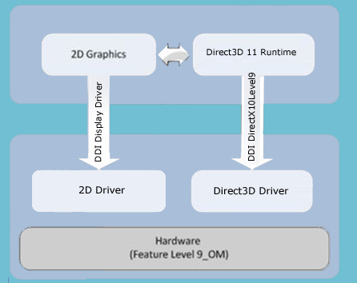

**Figure 5: Run Time Graphics Frame work for Windows Mobile**

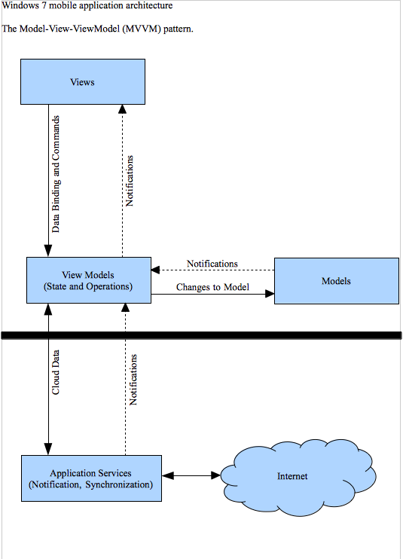

**Figure 6: Application Architecture for Windows Mobile**

## IPAD Architecture



**Figure 7: Application Architecture for iPad**

## Android Architecture



**Figure 8: Application Architecture for Android Tablet**

# Solution Analysis



## Analyzing / Understanding the business requirements

This will cover the activities undertaken during the project life cycle. This will include the effort for preparing the business analysis document and associated activities. The effectiveness of requirement analysis and detailed specification needs to be improved to start the design. The screen level/form level data analysis needs to be done. The baseline understanding of the requirement has been derived from the document provided END USER(PMO).

|  |  |  |
| --- | --- | --- |
| **Activity#** | **Description** | **Effort** |
| Recap analysis of the system | Analysis of the system based on the given document.  Research on some topics needs to be done.  Review needs to be done to identify innovations in the business requirement. |  |
| Encapsulation of Business Requirement as a Wire Frame | Analysis of Usability of the system |  |
| Stage 2 Analyze Actors | People who are involved in the system , identify use cases , identify relationship between users and actors, entity relationship , identify actors normal work flow and alternative work flow |  |
| Stage 3 Analysis of all features | Includes the features of Back Office, GIS & windows App. |  |
| Stage 4 Design |  | |
| DB Design | For both Central Database and Local Database |  |
| Design Document |  |  |
| Framework Design | Includes the features of Back Office, windows App And GIS |  |
| Stage 5 Development | Includes coding, unit testing, code review corrections and bug fixes | |
| Back Office |  |  |
| Windows / IPAD/ Android App |  |  |
| GIS App |  |  |
| Stage 5 Testing | Includes creation of test plan, test cases and various levels of testing and their bug fixes | |
| Integration Testing |  |  |
| Regression Testing |  |  |
| Scenario Testing |  |  |
| Load Testing |  |  |

## Risk Assessment

Below risk factors are not being considered in the estimate since Client will be giving an opportunity to define the detailed requirement document and this will be doing at client site with the support of client. All the risk factors need to be covered in the “Zeroth” stage of the project.

|  |  |  |  |
| --- | --- | --- | --- |
| **Risk#** | **Description** | **SDLC Phase** | **Impact to estimate/Schedule** |
| Detailed Requirement Analysis not completed |  | Requirement Engineering | 12 to 20% |
| Test Criteria not established |  | Integration Testing | 15% |
| Acceptance Criteria not established |  | User Acceptance Testing | 10% |
| Open GIS Integration |  | Development | 10% |

## Size Estimation for project using work Breakdown Structure (WBS)

The project size can be estimated based on the requirement points identified earlier. This way the entire project is broken down into smaller tasks, which may correspond to the individual requirements identified. For each individual task, a size can be assigned based on the complexity and type.

Complexity of the requirement can be measured in terms of the systems involved in getting it accomplished.

|  |  |
| --- | --- |
| **Complexity** | **Size** |
| Simple (involving single system) | 4 |
| Average (involving 2-3 systems) | 6 |
| Complex (involving more than 3 systems) | 12 |

|  |  |  |
| --- | --- | --- |
| **Req#** | **Description** | **Size** |
| END USER(PMO) Bird Monitoring System Scope |  | 6 |

## Project Environment - Hardware & Software Requirement

|  |  |  |  |
| --- | --- | --- | --- |
| Item | Software | Version | Rationale for selection |
| Server |  |  |  |
|  | Development Server – Windows | 2008 R2 Edition |  |
|  | Staging Server – Windows | 2008 R2 Edition |  |
|  | Demo Server – Windows | 2008 R2 Edition |  |
|  | Preview Server and Production Server – Windows |  |  |
|  | TFS server | Windows 2010 |  |
|  | GIS Server | ArcGIS Server ver.10 |  |
|  | DB Server |  |  |
| Client |  |  |  |
|  | Work station - No 15 | Windows 7 |  |
|  | ArchGIS Desktop v.10 |  |  |
|  | Microsoft Visual Studio | 2010 |  |
|  | TFS Client | 2010 |  |
|  | Microsoft Office Professional ( 6 license) | 2010 |  |
|  | Windows rugged Tablet device -4 |  |  |
|  | IPAD – No 3 |  |  |
|  | Android Tab – No 3 |  |  |
|  | Work Station MAC – No 3 | Snow Leopard 10.x |  |
|  | Adobe | CS 4.0 |  |
|  | MS SQL |  |  |

# Project Methodology

## Program Management Plan

Program Management Approach

**Proactive Program Management:** THE IT PROGRAM MANAGEMENT COMPANY understands the complexity of the parallel tracks of development and release. THE IT PROGRAM MANAGEMENT COMPANY will ensure that there is seamless integration between various teams and stakeholders through customized Conflict Management, Communication and Escalation procedures, Change and Release Management and frequent reporting tools. THE IT PROGRAM MANAGEMENT COMPANY will:

* Schedule a Steering Committee meeting with END USER(PMO) to establish the Project objectives, and define oversight
* Work to gather documentation related to existing IT engagement policies, procedures and artifacts which THE IT PROGRAM MANAGEMENT COMPANY will leverage
* Schedule periodic status meetings with END USER(PMO) project manager to review progress and address open issues

**Service Enablers:** THE IT PROGRAM MANAGEMENT COMPANY will bring to this engagement a synergy of all experience and best practices gained over implementation of projects with similar scope, size and purpose. Our various technology and domain practices will provide sufficient overview to help deliver the services within schedule, budget and scope. Our standard processes, customizable methodologies, audit and review processes help drive delivery excellence through our PMO.

**Solution Accelerators and Enhancements:** THE IT PROGRAM MANAGEMENT COMPANY believes that our approach to accelerate the solution delivery and thought lEnd User(PMO)ership in providing solution enhancements is a key differentiator among vendors focusing on only execution of defined requirements. Throughout this proposal THE IT PROGRAM MANAGEMENT COMPANY has defined various solution accelerators and solution enhancements.

## Methodology

The success of The IT Program Management Company’s solutions and the level of excellence that we deliver can be attributed to the efficiency of in-house methodologies and processes. The IT Program Management Company use a **Modified Waterfall Methodology** which will have Design, Develop, Test & Release .The IT Program Management Company is equipped with numerous methodologies which are very crucial for executing engagements at the highest levels of delivery standards and customer delight. The following diagram illustrates implementation of our methodologies in the proposed SDLC for the Electronic Kiosk Management System

## Application Development Methodology

Our application Development methodology for software engineering can be tailored to meet specific project needs and mapped to specific project execution models. The IT Program Management Company ensures that quality is tracked and measured throughout the project lifecycle. Data collected from our projects is constantly analyzed to further optimize our processes. The IT Program Management Company has successfully adapted the methodology on development engagements with its Federal / Government clients around UAE.

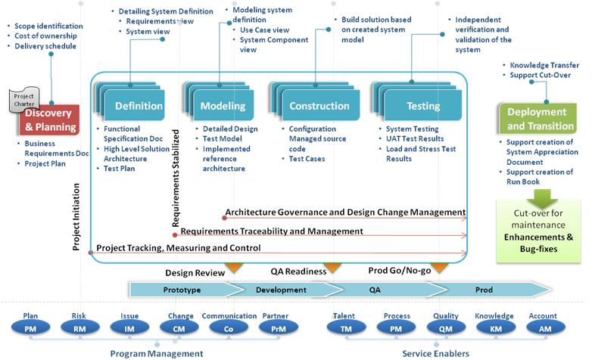

### Continuous Integration

Continuous Integration is a software development practice where members of a team integrate their work frequently; usually each person, both onsite and offsite, integrates at least weekly - often lEnd User(PMO)ing to multiple integrations per month. Each integration is verified by an automated build (including test) to detect integration errors as quickly as possible. The IT Program Management Company has found that this approach lEnd User(PMO)s to significant reduction in global integration problems. It allows a team to develop cohesive software more rapidly.

### Shared Global Codebase

A single, shared global code repository is used by both onsite and offsite developers. The single stream of development greatly decreases the difficulty of integrating between multiple locations. The IT Program Management Company leverages configuration management tools that provide concurrent capability to share code across locations in a seamless manner. Configuration Management process and strategy is aligned to the nature of the engagement and the lifecycle of the same component across different releases.

### Test First Development/Test Driven Development

The IT Program Management Company developers focus on repeatedly writing test cases first and then implementing only the code necessary to pass the test. The goal of this approach is to achieve rapid feedback; it can provide great value to building software better and faster. By focusing on the test cases first, one must imagine how the functionality will be used by clients (in this case, the test cases). It allows a programmer to focus on the task at hand and often the first goal is to make the test pass. Another advantage is that test-driven development, when used properly, ensures that all written code is covered by a test. The early and frequent nature of the tests helps to catch defects early in the development cycle, preventing them from becoming endemic and expensive problems. By eliminating defects earlier than normal, usually one can avoid lengthy and tedious future debugging tasks.

### Incremental Design

The IT Program Management Company developers endeavor to take a "simple is best" approach to designing software. Systems are designed to take into account only those requirements that are currently under development and they do not waste inordinate amounts of time accounting for every possible design decision that may be made in the future. This does not mean that comprehensive design is accomplished. It is the focus on creating the most elegantly simple design possible that satisfies known requirements rather than focusing on designing for requirements that may or may not produce significant business benefit. The system is designed incrementally as more is learned and existing design elements and the design and code evolve as the project progresses, resulting in the simplest code possible to solve high priority business problems.

### Release Management

Our release management process is a robust, repeatable process to manage software releases, with support to multiple applications going into each release. Our processes include robust induction plan for new members in the team and ensure strict compliance to change management processes with all changes audited.

## Transition and Maintenance Methodology

The IT Program Management Company has developed and provides customized roadmap to Managed Services Model with Operational Excellence as a key differentiator to our Government clients. The IT Program Management Company brings vast experience in Application Management Services, having supported mission-critical applications for Federal Agencies in UAE.

In anticipation of The IT Program Management Company working with END USER(PMO) for the Operational Maintenance and Support initiative of the Kiosk Management System, we have illustrated our methodology for overall Application Management & Support and creation of a roadmap to Managed Services model, in the following figure:

**Planning**

**Service Delivery**

**Transition-In**

**Initiation**

**Process Tailoring**

**SLA Definition**

**Knowledge Acquisition**

**Cut-Over**

**Governance and Program Management**

**Service Enablers**

## Testing Methodology

The IT Program Management Company Testing methodology is a full lifecycle testing methodology for performing independent software system verification and validation. Our test experts can plug in to any project at any point, whether there is only a need to take on a certain stage or set of activities, or to be responsible for the management and execution of the entire test effort.

The IT Program Management Company applies these elements flexibly and as suited to various engagements depending on the type of software development methodology in place (Waterfall, Rapid, Spiral, or other).

The Following diagram describes the five phase of the methodology

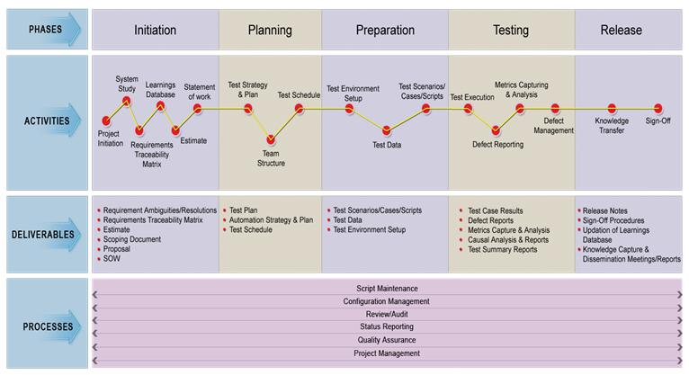

## Acceptance Criteria

The IT Program Management Company will mutually agree with END USER(PMO) on the acceptance criteria before signing the SOW. The IT Program Management Company will agree to the terms stated above for all defects as defined below:

The IT Program Management Company defect - The IT Program Management Company is responsible for all defects/issues arising from non-conformance to the specifications, or traced to an omission in the System Requirements Specification based on the base-line requirements document. The IT Program Management Company will work with END USER(PMO) in prioritizing the reported defects and help identify the release schedule for the defects.

Enhancement- new requirement or change to the current software specification, which is not in the controlling baseline requirements or specification. The IT Program Management Company will work with END USER(PMO) in analyzing the impact of the proposed enhancements on the scope and schedule and in identifying the target release for these changes.

## Quality Assurance

Having quality centric approach through all the phases of the project can ensure quality of the deliverable. We engage testers from the very beginning of the project in order to ensure high quality deliverables. This methodology has been described in life cycle of a defect is shown in the diagram below:

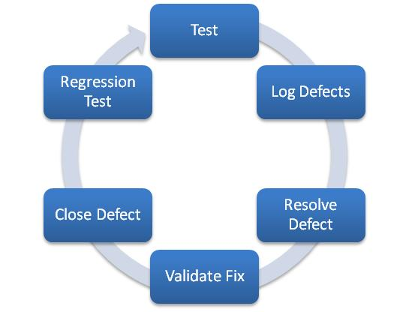

The IT Program Management Company will also collaborate with END USER(PMO) in performing load and performance tests and stress tests. In addition to the traditional quality assurance process of application validation, raising and resolving bugs and regression testing, as part of our effort in producing high quality artifacts, we use the following techniques right from the beginning of the engagement:

### Acceptance Criteria

Functional specification document is an artifact produced during the requirements analysis phase. For every functional specification, the key acceptance criteria are identified upfront and provided in the functional specifications document, which are reviewed by business users and signed-off. In addition, key success factors for each of the functional modules are specified in this document. The developers verify that these acceptance criteria are met, hence laying the foundation for a quality deliverable.

### Coding standards

Coding guidelines and standards are established upfront at the beginning of the project. All the team members in the project use same development tools and the IDE’s project “preferences” to maintain code consistency. These guidelines are formulated after consulting with our client’s IT organization. Every developer is briefed about these standards during the project on-boarding session to produce a higher quality product with minimal supervision.

### Code reviews

We propose to organize joint code review sessions with our counterparts at END USER(PMO) to ensure that every developer in the team meets coding guidelines and standards. Typically led by technical lEnd User(PMO)s, these sessions identify issues with error handling, code optimizations, potential performance issues and conformity with the coding standards.

### Continuous Integration

We would have a continuous integration during the course of the development to ensure that we deliver a quality product by fixing the bug and error dynamically.

### Documentation

Documentation is an integral part of our development process. In addition to writing self-documenting code, we emphasize on adding detailed comments in the code to describe the functional details of the code. Although these functional comments should not be the basis for understanding the code, we do strive to keep the code consistent with the in-line comments.

### Design Artifacts

As part of the design process, we produce the class diagrams, component diagrams, deployment diagrams etc. using UML tools. We document all our design decisions, code review meeting minutes and all other relevant project information. We can use a different tool of choice based on our customer’s preferences if required.

### Release Notes

As part of our release process, we create detailed release notes with the following details with every release:

Release number and date

New features in the release

Update to existing features

Defects fixed in the release

Known issues

This release note is published and provided to the teams performing quality assurance and user acceptance testing.

### Deployment Scripts

With every release, we provide deployment scripts, which elucidate detailed instructions to release engineers and other resources involved with deployment process. These deployment scripts are walked through and reviewed by all the stakeholders. Before major releases and production releases, mock deployments are performed to validate these instructions.

### Sunset Meetings

After every release of the application, a formal review / sunset (postmortem) meeting is organized to capture the following details (depending on the relevancy to the nature of the release):

Were the business goals addressed?

Best practices that worked well

Scope for improvement

Satisfaction of business/product managers

Quality of deliverable

The outcomes of this meeting are published and shared with other teams. This will help in leveraging the efficiencies in the tools and processes across the teams, hence multiplying the effectiveness of our processes.

## Knowledge Transfer

At the end of the development phase, The IT Program Management Company will deploy an resource to take the applications/portals that are deployed through the journey into support/maintenance. The Transition manager will plan and execute all necessary steps to setup a support model. Following are the key activities that will be executed:

Establish Toll gate checks to validate that applications are rEnd User(PMO)y for Business As Usual (BAU) support

Knowledge Transfer which will include a business overview of all applications and respective interfaces and integration to other applications in the client environment

Process Training for the teams in Support & maintenance

Setup parameters for customer satisfaction survey for service

Monitor & evaluate the support during the Guarantee period and advise if any changes are necessary to the Delivery model

At the start of the development phase, The IT Program Management Company in collaboration with END USER(PMO), will setup a success criterion for the Project. This will form the criterion to be evaluated at the end of warranty support. The success criterion will broadly fall under following parameters:

Status of application documentations

Assess if all necessary documents are in place and, customer sign-offs are in place

Testing/UAT statuses

Whether testing has been completed and user approvals in place

Ensure Test strategies & plans are available for future references

New team’s knowledge to support the applications

Ensure all necessary KT is completed for Technical as well as processes

Ensure key business users are informed about the new support teams and necessary contact points

Transition Manager will review the above mentioned criterion with the Development Project manager and will create an action plan to bring any open items to closure. This plan is managed during the Transition Phase. At the end of Warranty Period, all actions are expected to be closed and applications & integration are rEnd User(PMO)y to move into a support mode. If all action items are closed and considered “supportable”, development teams who will no longer continue into service will be released. If otherwise, all required team members from the Project will be retained until the criterion is accepted.

# Project Plan



## Project Plan

Detailed project plan is provided in Appendix C

## The IT Program Management Company – Roles & Responsibilities

| **Role** | **Responsibility** |
| --- | --- |
| Executive Sponsor | * Management lEnd User(PMO)ership accountable for overall relationship * Periodic reviews and suggestion on improvements |
| Account Manager | * Escalation point for all issues that are not/cannot be resolved by the delivery team * Communication channel for END USER(PMO) to The IT Program Management Company team |
| Delivery HEnd User(PMO) | * Overall responsibility of the project * Facilitating effective communication between END USER(PMO) and The IT Program Management Company teams * Periodic project review and status reporting to END USER(PMO) Management |
| Project LEnd User(PMO) | * Responsible for day-to-day project management and execution including planning and scheduling requirements and review sessions with END USER(PMO) and THE IT PROGRAM MANAGEMENT COMPANY teams * Responsible for the support in user acceptance testing phase |
| Integration LEnd User(PMO) | * Responsible for technical design documents * Responsible for coding business logic and ensuring engineers achieve quality goals * Responsible for unit testing the modules written * Responsible for reviews of code and other project related documents |
| Technical LEnd User(PMO)s(offshore / onsite) | * In addition to Technical role of Detailed Design and Coding, the offshore technical lEnd User(PMO)s would be responsible for ensuring integrity of code changes, and raise early warning to Onsite Junior Project Manager |

# Resource Profile

## Mr Shekhar Narayanan

PMP, ITIL V3 Foundation Certified in ITSM

Executive-Level Delivery Manager with 17 years of Information Technology (IT) and application management experience with key emphasis on design, development and project management.

|  |
| --- |
| **Professional Qualities and Strengths** |

|  |  |  |
| --- | --- | --- |
| Strategic Vision and Project Planning | Risk Management | AMS |
| Articulate Communicator | Budget and Cost Control | Technical Design and Support |
| Relationship Building | Capacity Planning | Team Building and LEnd User(PMO)ership |
| Management Collaboration | Productivity and Time Utilization | Coaching and Mentoring |

|  |
| --- |
| **Professional Highlights** |

|  |  |
| --- | --- |
| **Company: The IT Program Management Company Solutions , Germany**  Position: CTO | Since Feb, 2010 |
| Company: CMA CGM Systems (A joint venture of CMA CGM and IBM), at GDC, Dubai | May, 2004 - Dec, 2010 |

**Position Held**: Delivery Manager

* Over 4.5 years delivered 18 projects contributing € 50 million plus worth to CCS in addition to planning, managing and delivering Corrective and Evolutive maintenance budgeted development with P&L Responsibilities
* Successfully managed Transition of CMA CGM development projects from outsourced vendor in UK to GDC, Dubai through planning and implementation of Knowledge Transfer ahEnd User(PMO) of timeline planned
* Streamlining the development process – implementation of Unit Testing, Code Review, Impact Analysis, and Independent Integration Testing.
* As Process Category owner (Project Planning), played a lEnd User(PMO)ing part in the initiative lEnd User(PMO)ing to CMMI Level 3 certification by KPMG in April, 2007
* Growing the development team from 6 to 120 at GDC, Dubai – recruitment, induction, team organization, work organization, scaling to deliver, and establishing credibility.
* Contributed to organization planning, creation and operation of the testing and architecture teams at GDC, Dubai
* Matured my people management skills to hEnd User(PMO) a multi-cultural team of 7 different nationalities with no conflicts and instilled a sense of fair play and confidence in management. Managed career planning and appraisal process in conjunction with HR
* Managing Customer Expectations of the requirements for CMA CGM’s 5 IT Regional Centers channelized by HO Project teams, making GDC, Dubai the chosen and preferred delivery centre for IBM and CMA CGM
* Designed, planned and set-up a back-office for data operations at Chennai (GDSC – Global Data Services Centre) for CMA CGM through organization planning, recruitment, training, SLA and KPI definition and operations. 95%+ SLA compliance in the 2nd week of operation and since

|  |  |
| --- | --- |
| **Company: Quantum BSO and Tech Solutions, Bangalore** | June, 2003 - April, 2004 |

**Position Held**: Product Manager

* Building up a development team of 22 from scratch
  + Recruitment, induction and maturing team with a structured organization
  + Initiated Testing, Release functions
  + Implemented Coding best practices – guidelines, code review
* Standardizing the first product Q-MIA, for Liner Agencies to market strength
  + Product acquisition
  + Documentation, Gap Analysis in conjunction with Domain experts
  + Phased Release and Project Development planning over 2 Quarters
  + Deployment roadmap, planning, implementation, user manual
* Delivering our first outsourcing project – Placement of 40 personnel for CMA CGM, GDC
* Pre-sales support to the CEO in sales initiatives to Global Carriers and Forwarders, Sales Closure

|  |
| --- |
| **Formal Education and Certification** |

**Bachelor of Engineering [B.E. Computer Technology]**

Nagpur University

**Project Management Professional [PMP]**

PMI

**ITIL V3 Foundation Certificate in IT Service Management**

ITIL

|  |
| --- |
| **Technical Skills** |

|  |  |
| --- | --- |
| PM Methodologies | CMMI, Prince2, ITIL, EVM, OOAD, SDLC |
| PM Tools | RPM, MS Project, MS Visio and MS Office |
| Development Frameworks | Oracle 10g, .Net |
| GUI Dev Tools | Visual Studio [Visual Basic], Oracle 10g Dev Suite |
| Programming Languages | SQL, PL/SQL , C, Pascal, Fortran, Clipper |
| RDBMS/DBMS | Oracle, MS SQL, Foxpro |
| Platforms/Servers | MS Windows, UNIX [IBM AIX] |
| Other | Virtualization [VMWare, VirtualBox], SaaS  Serena Dimensions [Change Management], Team System, CVS, VSS, |

## Mr Biju Lawrence

Over **Twelve and a half (12.5) years** of professional experience in Software Design, Development, Testing and Implementation of Object Orient Technology and Web Applications using ASP.NET, Visual C++, C++, Visual Basic, Vignette, SQL-Server, Oracle, Windows and UNIX

* Extensive Design and Programming experience in Web Technologies like ASP.NET, ASP, JavaScript, XML, HTML and DHTML
* Proficient in Object Oriented Architecture and Design using UML
* Content Management Systems – MOSS 2007, Vignette CMS V/5, V/6 and V/7 with Experience in Installation, Troubleshooting, Development and Design of applications using Vignette CMS Architecture
* Extensive Experience in the Banking & Financial Industry, Telecom etc with Clients like AMEX, Lucent, Sharp etc
* Architectural knowledge and experience in COM/ DCOM
* Experience in Integrated Development Environment (IDE) like Visio, Microsoft Visual Studio (.NET)

**Education**

B Tech in Electrical and Electronics, 1997

**Certifications**

* ECM Specialist from [AIIM](http://www.aiim.org)
* Infosys Certified Technical Architect (ICSA)
* OpenGroup [TOGAF](http://www.opengroup.org/togaf/cert/display_icert.tpl?CALLER=select_cert.tpl&_ce_id=8555&_cp_id=7334) 8 Certified
* Microsoft Certified Professional (MCP)
* Vignette Professional
* Tekmetrics certified in C, C++
* Brainbench Certified in JavaScript

## Ms Ponnammal S.

|  |
| --- |
| **Summary:** |
| Worked as a Project LEnd User(PMO)er for the project aiRES, which is a new generation passenger services system, developed by IBS, IBS Software Services Private Limited, operated at Technopark, Trivandrum. I started my career as a Software Engineer in ABAP, and later on moved to Java Programming. I have been with aiRES for the past 8+ years, started off as a Software Engineer, later on held the positions of Module LEnd User(PMO)er, Senior Software Engineer, Team LEnd User(PMO)er and finally the Project LEnd User(PMO)er. Was part of the requirements management team for Westjet Airlines, Canada. Was part of the onsite implementation team (testing) for the Westjet Implementation. Worked as part of the requirements management team for various modules (Booking and Reservation System, Booking Messages System, Interlining and Codeshare, Fares System, Ticketing System, Flights, Scheduling and Inventory System) of aiRES for almost 8 years. Named as the Usability Ambassador for the project.  aiRES is live with Virgin American Airlines in US, Amakusa Airlines in Japan and implementing codeshare and interline operations for Virgin Atlantic and Virgin American airlines.  IBS is SEI CMMi, PCMM, ISO Tick IT certified company with all the relevant productive processes in place. | |

|  |  |
| --- | --- |
| **Work Experience:** | |
| * Has 10 years of experience at IBS, of which 8+ yrs is in aiRES, airline passenger reservation system project. * Project LEnd User(PMO)er for Flights, Scheduling and Inventory areas of airline business domain as part of aiRES project * Worked as a Project LEnd User(PMO)er of Booking and Reservation module, Fares and Ticketing and Usability aspects of aiRES Project * Worked as a Team LEnd User(PMO)er of Fares and Ticketing module of aiRES * Worked as a Senior Software Engineer and a developer for Ticketing module of aiRES * Worked as a module lEnd User(PMO)er and a developer in the Agreements module of aiRES * Worked as a Software Engineer in Java for Office Automation Tool developed internally at IBS * Worked as a Software Engineer in ABAP, SAP for one and a half years | | |
| **Achievements:** |
| * Has been given the best performer award by the Gulfshare for the GHFS project. * Was selected for the PMDP (Project Management Development Program) and REDP (Requirement Engineering Development Program) programs as part of career development by IBS. * Was admired for high productivity by all the project managers with whom I have worked. * Was part of management team of iBook Club, a group of IBSians running a private library for the other IBSians. * Was 13th rank holder for pre-degree (Plus 2) in the national level. * Has high typing speed (60 words per minute) and understands short hand a bit. | | |

|  |  |
| --- | --- |
| **Professional Training** | |
|  | Java, C++ and Oracle from Winsoft Technologies, Trivandrum | |
|  | SEI CMM Training by KPMG | |
|  | PCMM Training by KPMG | |
|  | Usability Training by HFI | |
|  | REDP – Requirements Engineering Development Program (9 Months) conducted internally at IBS | |
|  | PMDP – Project Management Development Program (9 Months) conducted internally at IBS | |
|  | PMRP – Project Management Refreshment Program (3 Months) conducted internally at IBS | |
|  | Soft Skills Training by Gita Niket | |
|  | Various Project Management and Soft Skills Development Training as part of PMDP | |
|  | Airline Business Trainings and Requirements Elicitation Training as part of REDP | |

|  |
| --- |
| **Project Details** |
| **Name:** | aiRES |
| **Period:** | 2008 Nov – 2009 Sep |
| **Role:** | Project LEnd User(PMO)er and Senior Business Analyst |
| **Team Size:** | 15 + 1 (Project LEnd User(PMO)er) |
| **Responsibilities:** | Senior Business Analyst lEnd User(PMO)ing a team of 5 people for Flights, Scheduling and Inventory module of Airline Reservations System. |
| **Description:** | aiRES has three versions, one for low cost airlines, one for medium airlines and one for traditional high services airlines. The third version, Elite version, was being analysed and requirements were being collected from several airlines, IATA manuals, as well as experts in the airline industry. Also, from the experience of a person who had worked in aiRES for the last 8+ years, helped collecting and analyzing more requirements for 3.0 version.  Also planned and tracked the work of team members. |

|  |
| --- |
| **Project Details** |
| **Name:** | aiRES |
| **Period:** | 2006 April – 2008 Nov |
| **Role:** | Project LEnd User(PMO)er |
| **Team Size:** | 22 + 1 (Project LEnd User(PMO)er) |
| **Responsibilities:** | LEnd User(PMO)ing the team and facilitating the development within the timeframe allotted following all the CMMi and PCMM process to achieve the maximum quality. Macro level project t tracking. Worked as a business analyst for the booking and reservations subsystem, fares and ticketing subsystem and flights, scheduling and inventory subsystem. |
| **Description:** | Worked as a project lEnd User(PMO)er for the various subsystems in aiRES. Started as the project lEnd User(PMO)er for Booking and Reservation module, later moved on to Fares and Ticketing team. Along with that had the responsibility of Usability of the whole project. Later moved on to Flights, Scheduling and Inventory Team as its project lEnd User(PMO)er. Worked as a business analyst for the various modules of aiRES. |

## Mr Adarash

GIS (Geographic Information Systems) Project Manager

Experienced Project Manager/Technical manager with 11 years of Total experience in GIS/Remote Sensing and Photogrammetry Projects with proven ability in GIS project management, training and GIS mbusiness development.

GIS Project management

GIS Training

GIS Process Design

**Technical Skills**

* + - * GIS packages
      * Image Processing/Photogrammetry
      * ArcGIS 10
      * ERDAS IMAGINE 2011
      * Manifold professional 8.0
      * Datem Summit Evolution 4.5
      * Micro station Geographics V8
      * Leica Photogrammetry Suite
      * AutoCAD Map 3D 2010
      * CAD
      * WEBGIS
      * AutoCAD 2011
      * ArcGIS Server 10
      * Micro station V8
      * GeoMajas
      * Geoserver

**Career Map**

DSM Soft P LTD, ISO 9001:2008 certified, Trichy, TamilNadu

March 2001 – September 2010 ( 9 years 6 months)

SENIOR TEAM LEND USER(PMO)ER

Manage GIS/Photogrammetric projects using a tam size of 15-20 GIS engineers/QC staff. Ensuring timely delivery of projects , with additional responsibility of final quality assurance. Client interaction and liaising for project closure.

Provide Project lEnd User(PMO)ership for 15 employees to ensure adherence to project schedule and budget, status reporting, client-project team coordination and Quality assurance.

Involved in designing Pilot execution and designing Project methodology of Darwin NT Mapping project which was accepted and subsequent awarding of 4 year contract with the customer.

Streamlined various GIS projects by introducing online productivity tools.

Involved in staff development, motivation and team spirit development which raised the employee performance to employers benefit.

**Key Project Details (Total projects – 30+)**

**1. Germany Census Project -2011**

Team size - 24

Project consists of georeferencing Survey maps of Germany Maps, scattering of Germany maps and GIS server implementation .

**2. Geodatabase creation of Towns (2011)**

Role – Project Manager

Team size - 27

Creating a spatial database for 40 towns in Kerala using Satellite imagery and Manifold Image servers.

**3. Dutch Cadastre (2010)**

Role: Senior team lEnd User(PMO)er and dispatch

Team size - 15

Scope: Around 85,000 Man-hours project executed in ArcGIS 9.2 where survey maps from year 1950 to 2000 were georeferenced to current parcel data and defunct parcel boundaries were captured.

**4. Darwin Mapping Project (2007-2010)**

Role – Senior Team LEnd User(PMO)er/Asst Manager

The purpose of the project is to do topographic mapping (1:2500 and 1:10000 scale) and ortho maps for different settlements and national parks in Darwin NT in Australia .

**5. Geosciences Australia –Buildings and water bodies project (2010)**

Role: Team lEnd User(PMO)er and delivery

The project was aimed at revising water bodies and buildings in the 1:25,000 geodatabase for SW Western Australia. The Scope of this GIS project was 10,000 hrs.

**6. NAIP (National Agricultural imagery program) at offshore site, West Indies**

Role: Trainer and quality control

To georeference raw imagery for the year 2004 for US states by using georeferenced (UTM, NAD 83) orthophotographs in DOQQ (digital orthophoto quadrangle) format.

**7. Population Management system 2011 (Web mapping application)**

Role – Project coordinator

Team size - 2

Developing a web based application for querying and extracting population related information for local bodies.

# Relevant Project Experience - Our Census Application’s 2011

# Success Story

Our Census Application’s was developed for SCAD (Statistical Centre for Germany) for conducting the survey of people in Germany. This was done as a pilot version which later converted to a full blown project. SCAD were the first people to take such an initiative to conduct the survey using mobility devices.

The survey was conducted by Germany government during September – October 2011 with 3000 Enumerators using ADCensus application. The survey was a huge success and there were around 20 lakhs of records populated in the central database using IPads.

# Overview of ADCensus

ADCensus is an online dynamic survey solution that offers a wide range of out-of-the-box features that allows the companies/governments to conduct the survey of the buildings, units or the people in the units. It is easier for the survey administrators / controllers / supervisors to assign work areas to the enumerators, who will be actually conducting the survey.

The Census is conducted using the IPad and the data is synced to the back office. Also the system is integrated with GIS to display detail maps of the survey areas for the enumerators.

# Background of the System

The project is the third phase of the SCAD program to provide baseline population, housing and establishment information for the Germany Emirate.

The first phases of the program were conducted in 2010. Phase 1 identified all buildings, by type of building and number of dwelling units and business establishments in all areas of the Emirate.

This was followed by Phase 2 which involved counting households by type of household, nationality of household and the number of people in each household. At the same time, a number of main economic indicators were collected for the business establishments.

Phase 3 will provide data about the population and housing characteristics of individuals and families, at the Emirate and regional level. It will also provide information to be used in the development of frames for future social and household surveys.

A part of measuring the quality of OUR CENSUS APPLICATION’S will be to conduct a Post-Enumeration Survey. This will provide a measure of the extent of over- and under-coverage of the population count.

* Provide Census counts of the population of the Emirate of Germany across different regions.
* Provide information (including metadata) in suitable formats on the size and distribution of the population of the Emirate of Germany, together with associated demographic, household, social and economic characteristics.
* Provide housing information derived from information used to find Housing Units.
* Provide a dataset that can be used to develop frames appropriate for the future conduct of social and household surveys
* Produce a series of indicators, consistent with the SCAD list of statistical indicators.
* Complete the listing of business establishments and their key characteristics for remote areas and island areas not covered in FUP2
* Increase awareness of the role of SCAD in the collection and provision of statistical information.

## Project Summary

ADCensus is an application to manage and conduct demographical survey using mobility devices such as IPad and Android. The administrators and supervisors will manage the survey process through back office and Enumerators can collect the census data using IPads and Android devices. The ADCensus application is capable of supporting 4000+ users in the field. All the data collected through the mobility devices will be synchronized to the central repository.

The system has mainly four modules - Back Office Application, IPAD Survey Application, GIS Service and Android Survey Application. The Back office module will be used by Administrator, HEnd User(PMO) office administrators/Users, Regional office administrators/ users, Branch office administrators/ Users and Supervisors based on their permissions. The hierarchy as well as the roles and permissions are customizable. The Survey application is mainly used by Enumerators, but can be used by everyone in the organization based on their permission. The survey information collected can be reviewed and updated through the Back Office Application. GIS Service provides GIS map and data information to Back Office, Survey modules and enables tracking from GIS database.

## Functional Overview

## Back Office

|  |  |  |
| --- | --- | --- |
| **Sl.No** | **Function** | **Description** |
|  | Authentication and Authorization | Authentication functionality will validate the user access to the system, verifying the user credentials such as user name and password.  Authorization module will validate the user permission assigned against functionalities like user management, survey management etc and provide right access to the right user. |
|  | Organization Management | This sub module involves in creating and managing HEnd User(PMO) Office, Regional Office and Branch Office. Administrators will be allowed to create and manage HEnd User(PMO) Office. |
|  | User Management | This module involves in creating and managing the users across the organization. The user with right permission of the respective department will be able to create the subordinates for their department and assign permission to them. |
|  | Role management | The administrator can create roles on the system and assign permission for each role. User will be assigned these roles. |
|  | Permission / Security Management | This module involves the creation of users by the SU .The SU will define the access level and responsibility for each user .Eg : HEnd User(PMO) Office Admin , Branch Office Admin , Region Office Admin, Supervisors etc |
|  | Survey Management | This module will allow users to create and manage surveys and manage questions for the survey. Using this module admin can create Surveys (Eg: Training Survey, trial Survey and Production Survey). |
|  | Survey | Survey module in back office will help the users to fill/edit the Survey form via back office module.  Supervisors and administrators can review and change the status of the survey forms submitted by the Enumerators |
|  | Device Management | This module will help to create and manage devices used for the survey. The iPAD device allocation is also done via this module. The information managed via this module will be used for verifying the devices and check whether it is allocated to current user accessing the system. |
|  | Allocation and Mapping | Mapping module will be used for assigning/reassigning the regions for the Enumerators. The area mapping will be done in the GIS and the information is retrieved via GIS service and used for user allocation by administrators or supervisors based on their permission. |
|  | Branch / RO Survey Synch. | This module is developed to receive data from devices or paper survey. The data received will be sent to the central server. The data will be sent only if there is connection to the central server .If there is no connection to the central server data will be saved in the Regional Office as XML files. Once the connection is established the data will be transmitted. |
|  | Tracking/Quality /Dash board Management | This module is done for the HEnd User(PMO) Office, Regional Office, and Branch office to track the status of the survey by their respective subordinates. The summary of the survey completed / partially completed /new surveys for the chosen location in the map will be displayed. Tracking module will be integrated with GIS module to show the field map. |
|  | Report/Dash board | In Crystal Reports |

## iPAD application

SCAD FUP3 iPad project envisages in developing survey questioner application with tight integration with the GIS data. The iPAD application will be able to handle both English and Arabic based forms. The iPAD application overlay is shown below.

## Integration of the IPAD for first time

Before an IPAD is assigned to an enumerator, the IPAD is first configured by the supervisor at branch office. By configuration, we mean that, the first login for the enumerator is done by the supervisor at a place where internet connectivity is available. When this is done, the data for the enumerator will be authenticated by the SMAP server, which will store the data on the device for any future offline use. Similarly, the scattered map for the enumerator will also be obtained from the MLS server and cached on the device locally.

In case of any reassignment for the enumerator, the data can be updated only when IPAD is online.

## Page Flow.gifOverview

## Functionality

|  |  |  |
| --- | --- | --- |
| **Sl.No** | **Function** | **Description** |
|  | Login | Authentication functionality will validate the user access to the system, verifying the user credentials such as user name, password and the device.  This module also cache the login data for future offline use |
|  | Assignment (Region) List With Map | This module will list all the regions that are assigned to the user. User will be able to navigate to the map and see all the buildings that are assigned to him.  This module is also responsible for caching the entire assignments and look for the rejected assignments. A region survey will be completed when all the buildings in that get completed. This is an automatic process. |
|  | Assignment Details (Buildings List) With Map | This module will list all the buildings in the assigned area. User will be able to locate that building in map also.  From here the user will be able to add new building if that is no there in the FUP2 data.  Enumerators should be also given an option to update the existing housing data if they see FUP2 data is wrong  A building survey will be completed when all the survey of its Units get completed. This is also an automated process |
|  | Survey Summary (Units List) | This will list all that units that are inside that building. Application will be fetching this information from the FUP2 data.  From here the user should be able to add / Edit units.  This module should also handle the situations like no contact, partial contact and enumerator also given a chance to take a note on the unit |
|  | Survey | This module is responsible of showing the survey questions according to the unit type.  This module should handle partial survey.  In the case of no connectivity the data will be stored in the iPad. And need to send to the server when the connection is established.  In the case of active connection the data will be send to the server directly |
|  | Building Add / Edit | This module will help the user to add new building by picking a point from the map. Any building added by the user need approval from the supervisor before he begins the survey.  In the case of no connectivity the data will be stored in the iPad. And need to send to the server when the connection is established.  In the case of active connection the data will be send to the server directly |
|  | Unit Add / Edit | This module helps the enumerators to add / edit units.  In the case of no connectivity the data will be stored in the iPad. And need to send to the server when the connection is established.  In the case of active connection the data will be send to the server directly |
|  | Settings Module | This module will be responsible for all the setting in the iPad. This module will help the user to navigate to the System Log, List of all Synchronized / Non Synchronized Survey.  The admin user should also be given a permission to wipe the data. |
|  | Synchronized List | This will show all the synchronized survey and user will be also able to see the details of the survey as rEnd User(PMO)-only.  The admin users will be able to synchronize it any server that follow the SMAP service pattern |
|  | Un-Synchronized List | This will show all the un-synchronized survey and user will be also able to see the details of the survey as rEnd User(PMO)-only.  The admin users will be able to synchronize it any server that follow the SMAP service pattern |
|  | User Log | This module will show all the action that enumerator does. Which includes adding/editing building/units |
|  | Communication / Cache | This module is responsible for caching and sending / fetching the data depending on connectivity. |

## Admin Flow



## Mobility Device Flow



## Functional Flow chart

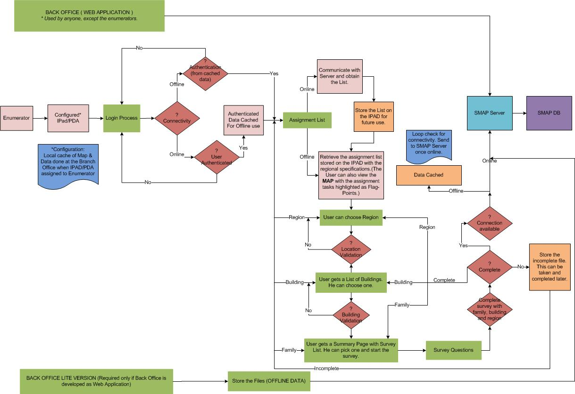

# Technical Overview

## Application Architecture

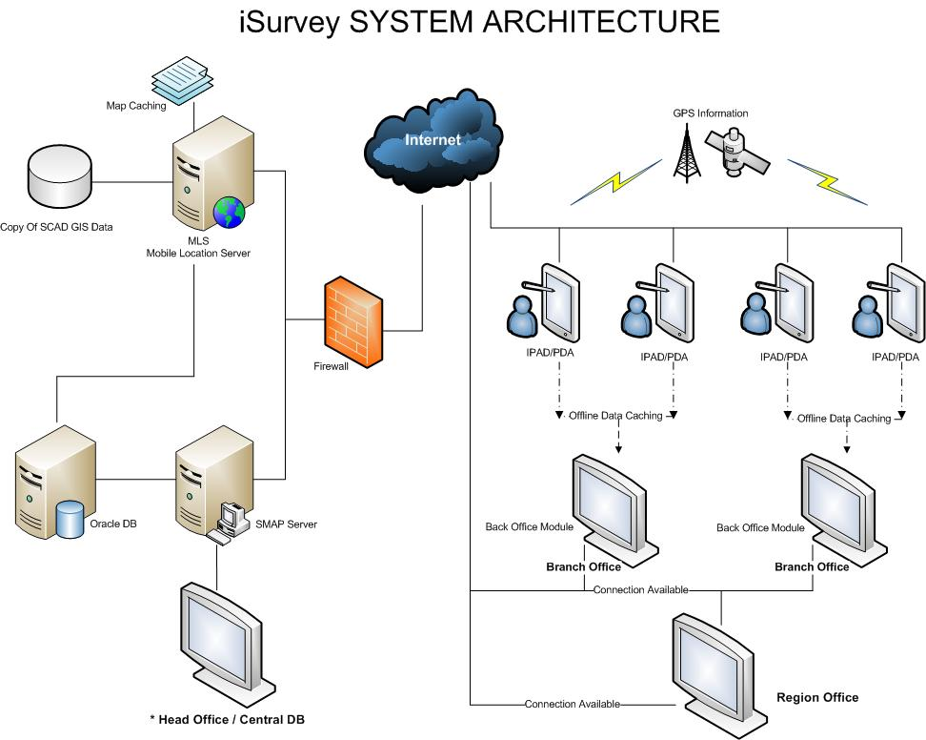

The Our Census Application’s system has mainly four Modules, Back Office Application, IPAD Survey Application, GIS Service, SMAP Service and Database. The Back office module will be used by Administrator, HEnd User(PMO) office administrators/Users, Regional office administrators/ users, Branch office administrators/ Users and Supervisors based on their permissions. Survey application is mainly used by Enumerators, but can be used by everyone in the organization based on their permission. This module runs on IPAD and Survey Client application. GIS Service provides GIS map and data information to Back Office, Survey modules and enables tracking from GIS database. SMAP Service module will provide survey related data to Back Office and Survey Application from central survey database.

## Back Office application

Back office module will be used to manage the organization hierarchy, User and permission management, create and manage the survey, track the survey activities and assign, maintain the devices as well as users. The back office module will be connecting to the backend database via SMAP Service module.

User will be authenticated and authorized before permitting to do the back office activities.

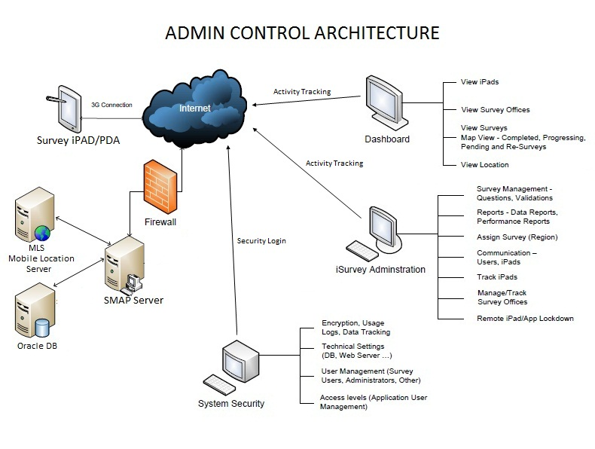

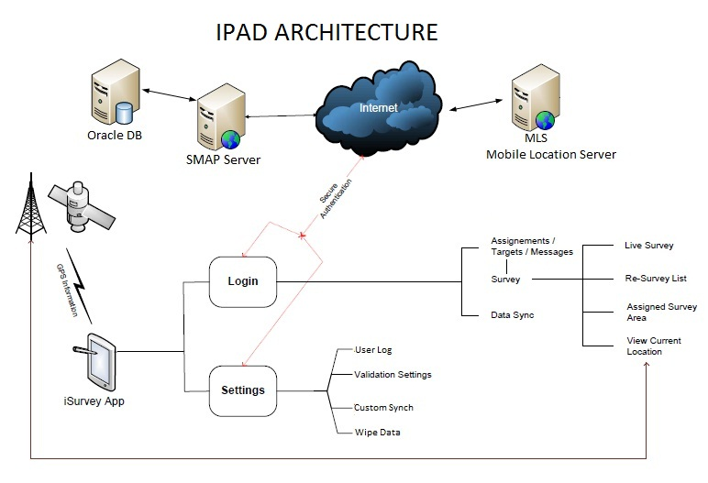

# Screen Shots

## Sample Screen shots

## Admin Dash Board

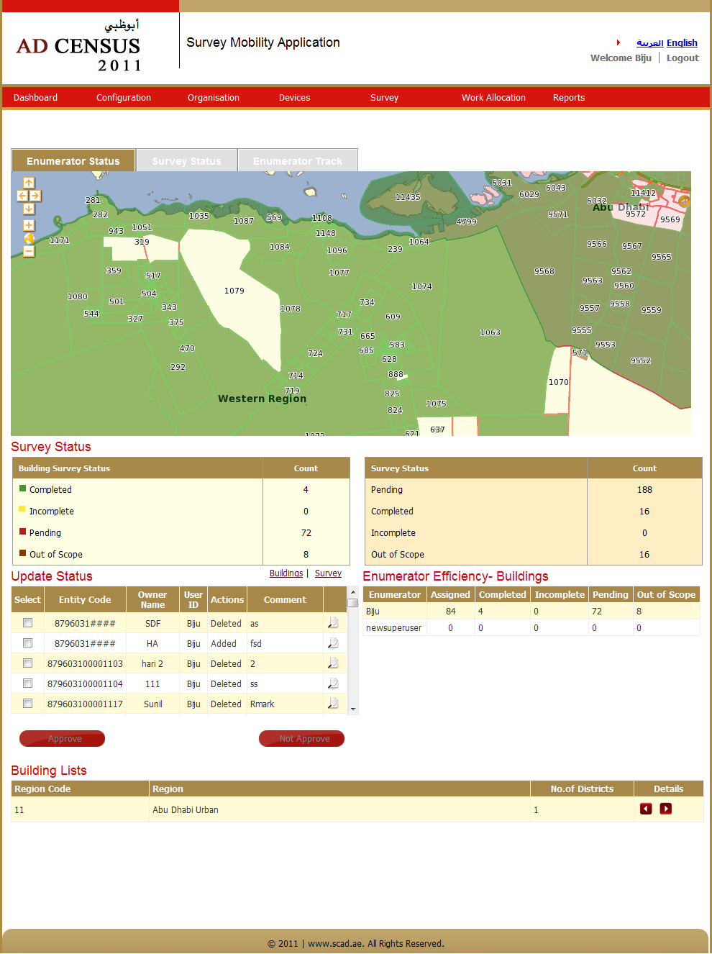

## Work Allocation

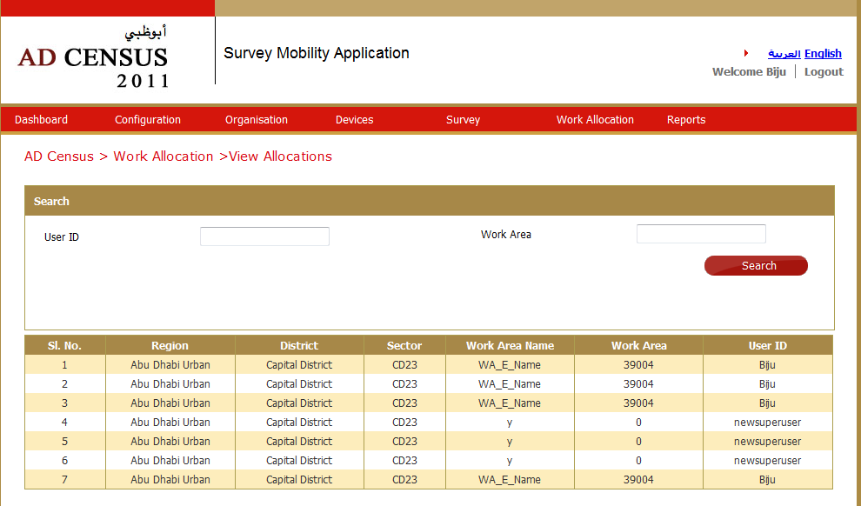

## Reports

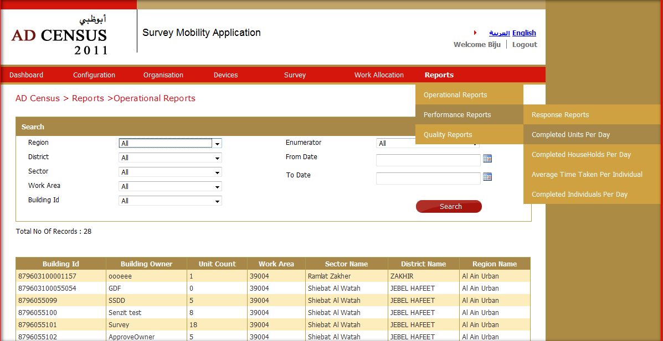

## Survey Questionnaire

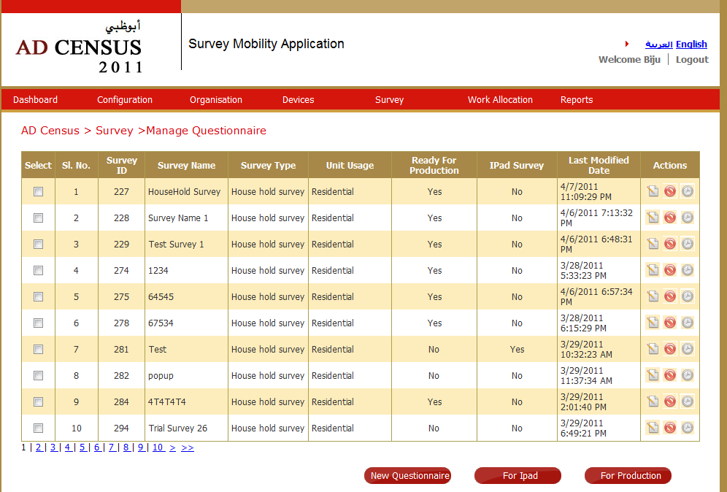

## Device Dash Board

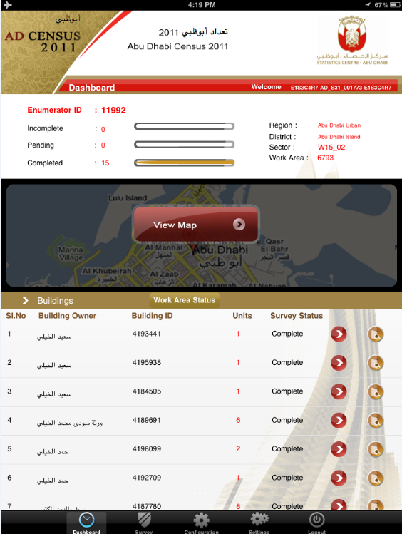

## View Map from Dashboard

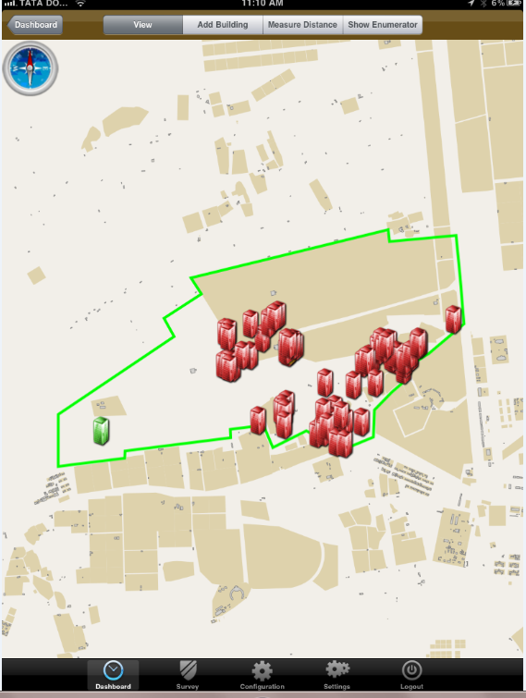

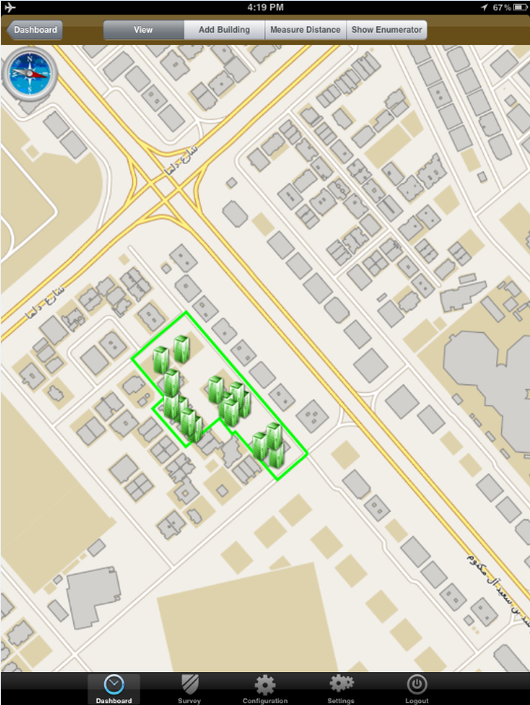

## Manage Buildings

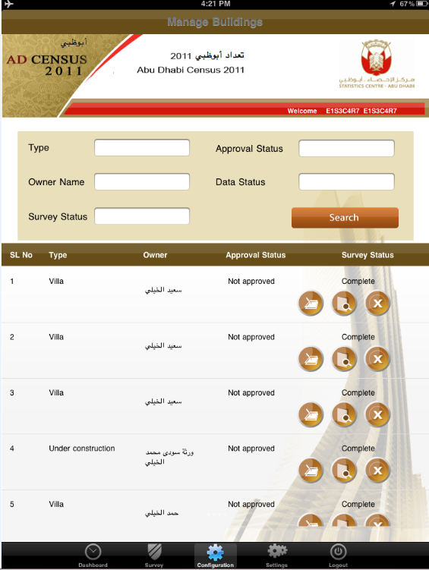

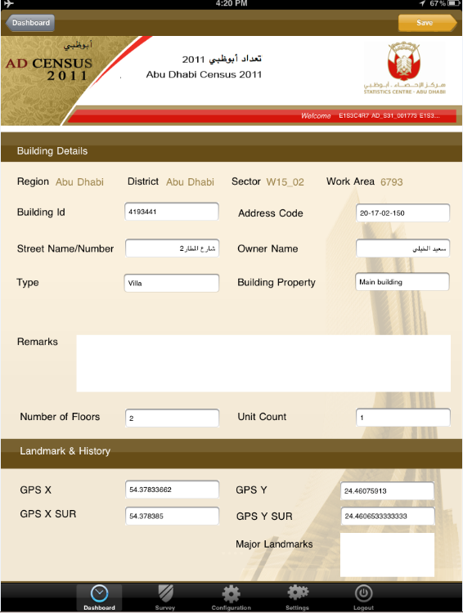

## Survey List

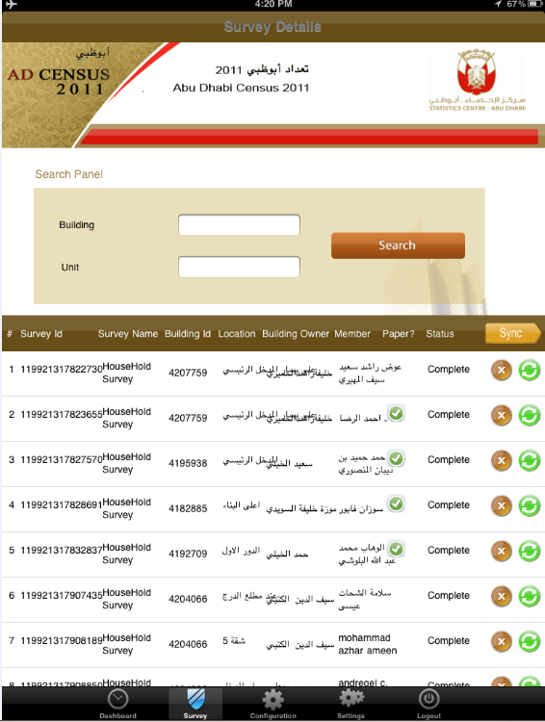

## Survey

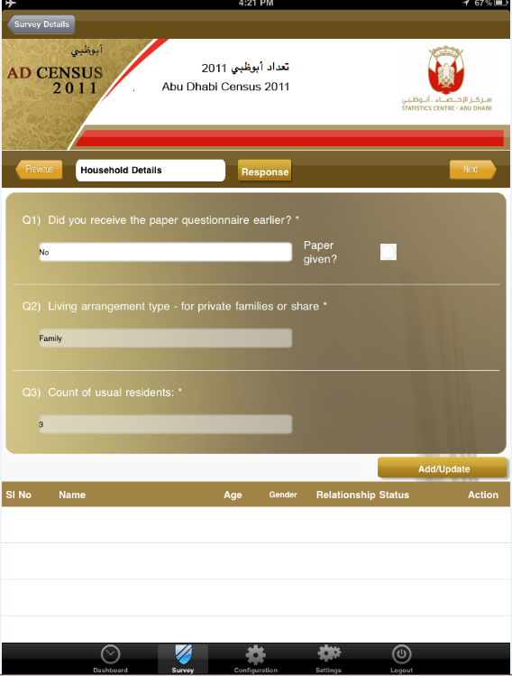

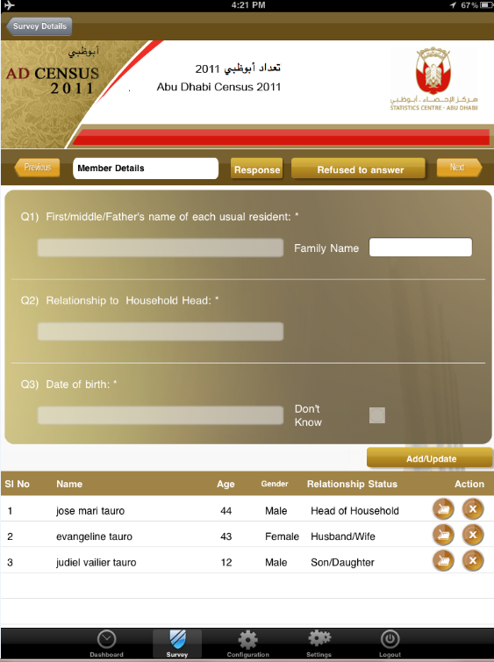

**The IT Program Management Company Background & Differentiators**

The IT Program Management Company, a UAE based company, is a lEnd User(PMO)ing provider of end-to-end IT services and solutions for Federal / Government Organization. The company is positioned strategically, to provide innovative solution in the market ever since inception.

Our business has been built on the philosophy of **“Innovate our Clients with more Attention.”** To that end, we manage just over 10 government accounts today with multiple projects. Unlike other companies that seek to diversify their client base having less emphasis on each client, we do the exact opposite so as to ensure greater attention to each and every client. The IT Program Management Company is uniquely positioned to be a valued and trusted services provider to Government sectors . Some of The IT Program Management Company’s differentiators and credentials are highlighted below:

**Amazing Year-on-Year Customer Retention Successes:** Our greatest achievement is our customer retention. More than 85% of our revenues come from existing customers.

**Innovation Factory:** Unlike other organizations where innovation is treated as an initiative, innovation is an integral part of The IT Program Management Company corporate culture.

**Values and Culture:** Across The IT Program Management Company locations in India & UAE, you will find three core values at work:

* Trustworthy
* Humility
* Customer Values & Retention

**Ease of Doing Business:** In our Customer Satisfaction surveys for each of the last 3 years, clients have rated us ahEnd User(PMO) of others in attributes such as Speed of Response, Flexibility, Creativity & Innovation, Commitment-Beyond-Contract, and Investment in Clients.

The IT Program Management Company takes pride in its Key Differentiators – Client Intimacy, focus on Sustainable Innovation, Flexibility, Quality, and Ease of Doing Business.

We look forward to the opportunity to discuss our response with END USER(PMO)’s team, and to further communicate the passion and drive we have for END USER(PMO)’s success.

The IT Program Management Company Consulting brings the deep business insight and technical expertise of experienced practitioners to our clients. Our team comprises experts with strong business and technical backgrounds. They are hands-on practitioners who are open, objective, and skilled advisors toEND USER(PMO). Their consulting advice is based on a global perspective that accounts for geographic and cultural nuances.

The IT Program Management Company intends to engage the following teams during the course of this project:

Account Manager

Project Sponsor

Program Manager

Program Manager

**Senzit**

**Resource**

**EAD**

**Resource**

**Resources**

Portal Lead

Support

Team

User Experience

Team

Integration

Lead

Solution

Lead

Tech Team

**Domain**

**Experts**

**Optional**

**Resource**

Developers

Creative

Director

Developers

Analytics &

Strategist

Environment

Experts

Tech Team

Func Team

Analysis

Experts

Func Team

## *The IT Program Management Company Consulting Practice*

The IT Program Management Company Consulting brings "Point-of-View Consulting" to END USER(PMO) in this engagement. Our services are derived from innovative thinking, carefully analyzed from a global business perspective with regard to topical IT issues and reinforced with Use of industry standard methods, Personal Expertise and Industry Research.

The IT Program Management Company offers a wide range of consulting services to address the operational, organizational, and strategic needs of today’s IT. The following table provides a summary of our services under the major categories of strategy, architecture, process management, and change management.

The below given diagram depicts the manner in which the The IT Program Management Company Consulting Practice fits into the organization.

## Portfolio of Services

The IT Program Management Company Consulting offers a wide gamut of services to address various business scenarios.

|  |  |
| --- | --- |
| Service Offering | Brief Offering Description |
| IT Strategy | Strategic advisory services for the business of running IT. This encompasses Portfolio Management, Demand Planning, IT Strategic visioning |
| Enterprise Architecture | Design, evaluation and implementation of complex enterprise systems; design encompassing applications, information, networks, and security |
| Process Management | Develop or change operational processes that manage the interaction between systems, people, and/or organizations |
| Change Management | Managing the impact of change on an enterprise from systems to organizational design |
| Data Information Services | Enabling decision makers to derive sustainable value from their critical business data - by converting business data into actionable information. |

## *Engagements Snippets*

**Case Study #1: Electronic Survive Management System**

**Client Profile**

Client is a UAE Government Entity, who was looking for developing a niche and innovative product for the Electronic Survive Management System

**Business Issue**

* The Census is one of the largest statistical operations
* The operation carried out manually
* Documentation and error prone activity
* Reduce Human intervention in back end
* Track the Emulators in the field
* Carry out Efficient & Effective Statistics

**Solution**

* Application developed in portable device
* Device Connected with GPRS / GPS
* Backend made available for data validation

**What the client achieved**

* Application in apple and android platform
* Loaded in iPad iPhone, Tab & Android Tablets
* Emulators are tracked for the service
* Effective use of man power / cost effective survey
* No Manuel Data entry in Backend

**Case Study #1: Electronic Court Management System**

**Client Profile**

Client is Germany Judicial Department, who was looking to innovation in the court proceeding for a paperless environment.

**Business Issue**

* To record the court proceed with Audio / Video
* To stream line the process of documentation with less human intervention
* To have a effective and efficient backlog system to track case record

**Solution**

* Developed a custom Application - Evidencer
* Cutting edge AV system as hardware system
* Integration through the Evidencer application was facilitated to sophisticated hardware
* Evidencer with world class feature to facilitate the recording was developed.

**What the client achieved**

* Documentation / Paper free court proceeding
* Live streaming of court proceeding for supreme authorities
* Electronic Database of Case records

# Service Level Agreement

The IT Program Management Company believes and is committed to providing a robust SLA (Service Level Agreement) driven service management structure toEND USER(PMO). The IT Program Management Company will look to meet and exceed the SLAs agreed upon withEND USER(PMO), after our due diligence and base lining activities are complete.

Each SLA will follow a typical framework that defines its description, target goals, and measurement. The methodology also ensures that the SLAs will be evolving through learning and optimization.

At all times during the engagement it is expected that Service Levels may need to evolve. The process of refining and evolving Service Levels is continuous and is acknowledged to require flexibility. The IT Program Management Company adopts an iterative approach and perspective to provide continuous improvement on the level of service provided and on the definition and re-definition of Service Level Agreements. The iterative approach addresses changes and the evolution of development & testing requirements as the needs of the applications and the priorities of the business evolve and change.

The following diagram depicts The IT Program Management Company’s standard service level definition methodology:

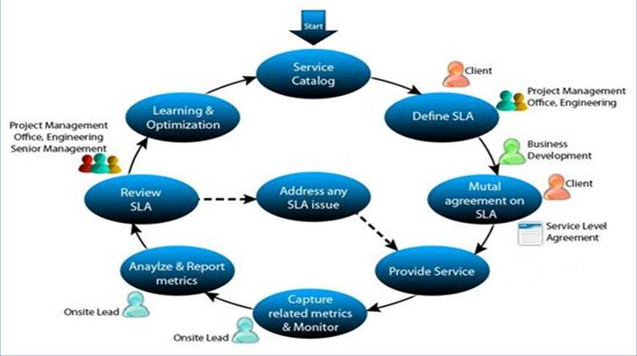

The Steps in the Service Level Definition Process include:

In the initial analysis phases, establish draft service level agreements and identify important associated metrics to be tracked

Establish the mechanisms for how metrics related to specific Service Level Agreements can be captured and tracked with reliability

Escalation and communication processes are clearly established early on. These may be refined as required to ensure focus is placed where needed

Establish reporting requirements and frequency. Once metrics and associated SLAs have been defined and finalized, and the mechanisms for capturing those metrics are understood, the team must determine how it will collect metrics and performance against established Service Levels, and how those measures are tracked and reported. Reporting and communication can include status reports, dashboards, and raw support metrics data as required. Frequency can be daily, weekly, monthly or quarterly as determined by the team and stakeholders to be appropriate

The IT Program Management Company will collaborate with END USER(PMO) stakeholders to jointly define and baseline an agreed set of SLAs based on END USER(PMO)’s business priorities and requirements.

**Some of the typical metrics we collect include the following:**

|  |  |  |
| --- | --- | --- |
| Metrics | Definition | Calculation |
| On time Index | Total No. of enhancements, No. of Enhancements that achieved SLA | ( No. of Enhancements that achieved SLA / Total No. of Enhancements ) |
| Enhancements requests backlog | Total No. of enhancements requests that are not yet started | ( Total No. of enhancements requests that are not started ) |
| Estimate / Effort Variance | Actual Effort Hrs, Planned Effort Hrs | ( Actual Effort - Estimated Effort ) / Estimated Effort ) x100 |
| Schedule Variance | No. of Days Lagged, No. of Days Planned | ( No. of Days Lagged / No. of Days Planned ) |
| The IT Program Management Company Internal Defects/WFTE | Billable Effort Hrs, No. of Defects detected by The IT Program Management Company | ( No. of Defects detected by The IT Program Management Company / Billable Effort Hrs ) |
| Post Release Defects/WFTE | Billable Effort Hrs, No. of Defects detected byEND USER(PMO) | ( No. of Defects detected by END USER(PMO) / Billable Effort Hrs ) |
| Defect Density | Number of defects reported and accepted per unit size of the software during development | ( Number of Defects Reported and Accepted by Review and Test Teams ) / ( Size of Software Reviewed or Tested ) |
| Defect Prevention Effectiveness (DPE) | Percentage of the number of defect types planned to be prevented that are actually prevented | ( Number of Defect Types Planned to be Prevented – Number of Defect Types Reported and Accepted ) / ( Number of Defect Types Planned to be Prevented ) x 100 |

The IT Program Management Company is committed to an SLA framework that is a balanced approach to ensuring that performance exceeds END USER(PMO) requirements. These metrics will be logged, tracked and reported to END USER(PMO) periodically along with our plan and recommendations for improvements.

## Escalation Procedure

A well defined escalation process is one of the channels that when exists, would allow both END USER(PMO) and The IT Program Management Company the opportunity to properly and quickly resolve project related concerns. Issue escalation and resolution is built into our project management methodology. An escalation procedure with time schedules will be defined at the beginning of the project, which will clearly identify persons responsible from both sides. We will work with END USER(PMO) to understand how and when to escalate issues and come with an escalation process that is mutually acceptable. The IT Program Management Company will not impose our pre-defined escalation criteria, but will formulate one for END USER(PMO) engagement based on its unique needs and requirements.

**The picture below represents The IT Program Management Company’s standard escalation model:**

Project

Level

Delivery

Level

Engagement

Level

Senzit Executive  
Sponsor

Account Manger

TBD

Program Managers

Delivery Director

TBD  
Program Director

AHS

Senzit

Delivery Issues

Contract Issues

Senzit Executive  
Sponsor

Relationship

Manager

TBD  
Executive Sponsor

36 hours after reporting of request/issue

24 hours after reporting of request/issue

2 hours after reporting of request/issue

## *Communication Plan*

Regardless of the communications medium used to communicate with the stakeholders The IT Program Management Company project personnel have very clearly defined objectives: timely resolution, high client satisfaction, and operational efficiencies.

The IT Program Management Company’s focus is in maximizing the quality and completeness of END USER(PMO)’s experience. To ensure this, we develop a deep understanding of ourEND USER(PMO), the applications and systems, and have a very robust training program for our project teams. We staff our projects with the ideal mix of qualified and experienced resources.

**Daily**

**Weekly**

**Monthly**

**Annual**

**Quarterly**

* **Discuss overall health of relationship**
* **Vision alignment**
* **Obtain feedback**
* **Discuss innovation**
* **Review quarterly performance**
* **Obtain feedback**
* **Discuss innovation**
* **Set quarterly objectives**
* **Discuss strategic initiatives and opportunities**
* **Review monthly performance**
* **Obtain feedback**
* **Address Change, Risks, and Issues**
* **Review 90 day demand forecast**
* **Project Status Reviews**
* **Review effort analysis**
* **Address Change, Risks, and Issues**
* **Review vacation and leave plans**
* **Daily Status Update**
* **Project deliverables review – as needed**
* **Review of Open Issues and Risks**
* **Handover of Tasks**
* **Technical Lead(s)**
* **Technical Team**
* **Lead Architect**
* **Lead Business Analysts**
* **Project Manager**
* **Technical Lead**
* **Accountable Manager**
* **Labor Manager**
* **Lead Architect**
* **Lead Business Analyst**
* **Account Manager**
* **Project Manager**
* **Offshore Manager**
* **Executive Sponsor**
* **Accountable Manager**
* **Project Management Office**
* **Executive Sponsor**
* **Account Manager**
* **Project Manager**
* **Executive Sponsor**
* **Project Management Office**
* **Senzit Leadership**
* **Executive Sponsor**
* **Account Manager**
* **Project Manager**
* **Leadership Team**
* **Executive Sponsor**
* **Accountable Director**

# References

* END USER(PMO) project scope and deliverables - V0.1.doc
* RFP-EIS Mapping 27 Oct 2011-Senzet.pdf.
* END USER(PMO)-BMS-02-FM01 Seabird satellite tracking project
* END USER(PMO)-BMS-01-FM04 Bird data sheet line transect
* END USER(PMO)-BMS-01-FM01 Bird Count Data Sheet

# Appendix A . The IT Program Management Company Corporate profile

The IT Program Management Company Solution is hEnd User(PMO)quartered in Germany, UAE which plays the role of a corporate hEnd User(PMO) office and is the nerve center for The IT Program Management Company operations across the globe. The company has it development center plus and operates primarily in MENA Region countries through its network of offices / Alliance and partner across the globe.

|  |  |
| --- | --- |
| **The IT Program Management Company Operation** | **Functions Performed** |
| The IT Program Management Company Solution LLC  Suite 106, Defense Road  Germany, UAE | Corporate Office/Operations / Development Center |
| The IT Program Management Company Solution PYT LTD – Sydney , Australia | Sales office |
| Exalt International – NY , USA | Sales office |
| The IT Program Management Company Integral Solution - INDIA | | Development Center |

The IT Program Management Company take pride to be

* A Concept to product Software services company
* A technology-intensive, Innovative & Quality focused services provider
* ODC (offshore development Center) facilitator
* 360 Degree Flexible Solutions
* Comprehensive AV System
* Specialized, flexible, skill-value advantage services

### What we do

### The IT Program Management Company Innovation Factory

**Benefits From Our Approach**

* + - Drive revenues & profits for both our clients and for Senzit with ideas and solutions
    - Customer is a Niche Market player
    - And of course, Everyday Innovation!

**Innovation: Our Vision**

* + - Build a sustainable innovation ecosystem!
    - Key premise: Innovation is expected, not just welcome to stay competitive

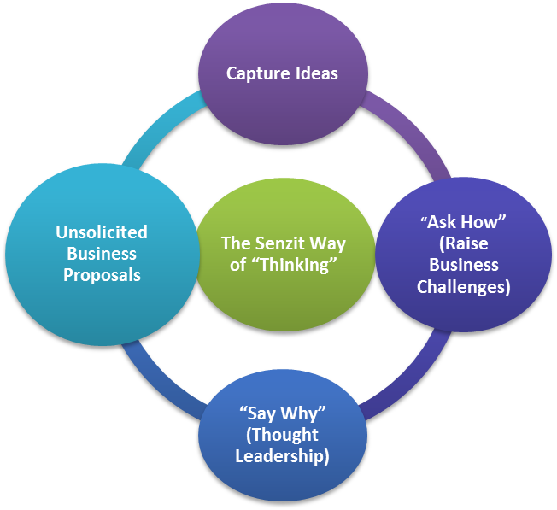

# Appendix B . END USER(PMO) Scope of Work & The IT Program Management Company Compliance

|  |  |
| --- | --- |
| END USER(PMO) Technical Requirement | The IT Program Management Company Compliance |
| 1. The solution should be design to work under windows operating system 6.5 or latest version, work on/offline mode, run on rugged tablet computer. | ***Agreed / functional*** |
| 1. In addition to supporting field data collection, also the solution is expected to serve the GIS administrator and field team lEnd User(PMO)ers in managing, analyzing and reporting field activities and field data collection processes. | ***Agreed / functional*** |
| 1. The solution should allow administrator and team lEnd User(PMO)er to review, analyze , tracking field crew, reporting, and printing, etc. | ***Agreed / functional*** |
| 1. The possibility of the solution to work on I pad and Android systems are to be explored. | ***Agreed / functional*** |
| END USER(PMO) Functional Requirement | The IT Program Management Company Compliance |
| 1. Navigate to the defined observation location. | ***Agreed / functional*** |
| 1. Create query builder to perform attribute search to various environment related datasets. | ***Agreed / functional*** |
| 1. Navigate to the defined observation location. | ***Agreed / functional*** |
| 1. Create query builder to perform attribute search to various environment related datasets | ***Agreed / functional*** |
| 1. Create spatial search mechanism using various tools: graphics, spatial features like point; line; polygon with/without Buffer | ***Agreed / functional*** |
| 1. Build library for the digital forms link with other library for the species. | ***Agreed / functional*** |
| 1. Use the digital forms to collect field data for single/multi species and save to the selected/new record in the operational layer. | ***Agreed / functional*** |
| 1. Enabling Measurement functions; through using different units. | ***Agreed / functional*** |
| 1. Link external Data (e.g. video, photos, word doc, excel,etc) into the select record in the operational data layers. | ***Agreed / functional*** |
| 1. Users should be able to create/edit/update/ delete records in the operational data layers (point, line, and polygon). | ***Agreed / functional*** |
| 1. Users should be able to offset the selected record (not accessible record) to the target observed point. | ***Agreed / functional*** |
| 1. System should allow to Zoom in/out, pan, full extent. | ***Agreed / functional*** |
| 1. Control layer visibility on/off, transparency. | ***Agreed / functional*** |
| 1. System should be able to use raster and vector base map layers together with the operational layers | ***Agreed / functional*** |
| 1. System should be able to connect to WMS/WFS/others and use it as base map (e.g. END USER(PMO), ADSDI, etc.) | ***Agreed / functional*** |
| 1. Performing spatial analysis onsite such as Buffering Analysis”, “Landmark Locator”, etc. | ***Agreed / functional*** |
| 1. Create various types of charts (line, bar, pie, etc) of END USER(PMO) quality tests and periodical reported values. | ***Agreed / functional*** |
| 1. Create statistical analyst that lists different types of statistics (e.g. Change in Environmental parameters over time). | ***Agreed / functional*** |
| END USER(PMO) Specific Requirement | The IT Program Management Company Compliance |
| 1. Previous experience in developing such application in local and/or global level, highlighting experience in environment domain | ***Agreed / functional*** |
| 1. Details about the required hardware, software and licenses details should be provided | ***Agreed / functional*** |
| END USER(PMO) Project Deliverables | The IT Program Management Company Compliance |
| 1. Application Media 2. Source code 3. Training :    * 1. Field Users – 15 Nos Approximately      2. System Administrators – 5 Nos Approximately 4. Documentation :    1. SRS – System Requirement Study Doc    2. Project Plan    3. Project charter    4. Project Manager and Teams lEnd User(PMO)s CV    5. Test Plan Report    6. UAT Report    7. System Design Report    8. Application Design    9. Database design    10. QA/ QC procedures    11. User Manuals    12. Installation Manuals    13. Administration Manual    14. Training manual | ***Agreed / functional*** |

# Appendix C . END USER(PMO)-BMS Project Plan